|  |  |  |
| --- | --- | --- |
|  | **BAHRIA UNIVERSITY, (Karachi Campus)**  *Department of Software Engineering*  **Mid Term Exam Lab- Fall 2021** |  |

Course name: **Computer Architecture and Logic Design Lab**

Course Instructor: **engr.** **Dr. Samar yazdani** Name:

Lab Instructor: **engr. Ramsha mashood** Class:

Max. Marks: **30** Reg. No:

Date: **1/12/2021**

Name = **Muhammad Junaid Saleem Qadri** E.no: **02-131202-057**

**NOTE: Create Folder of your name and enrolment (e.g.: student_enrolment). Place docx and code files with respective tasks names.**

**Task # 1:**

Write a program to create an ATM Machine System in MIPS Assembly that contains following features.

1. Create a PIN code
2. Balance Checking, Cash Withdrawal, Cash Deposits
3. Ask after transaction that if user wants to do more transaction or exit

Solution:

.data #decypt

option: .asciiz "\n1) CashDraw\n2) Balance Check\n3) Cash Deposit\n\tEnter any one option : "

opt: .word 3

id: .asciiz "Enter your PinCode : "

pin: .word 5862

invalid: .ascii "Your PinCode is Wrong"

balance: .word 25000

trans: .asciiz "\n\nFutur Transaction ? (0,1) = "

amount: .asciiz "Enter Amount : "

over: .asciiz "Your Balance is Low"

success: .asciiz "\nSuccesful Deposit"

printbalace: .asciiz "\n\tYour Balance is : "

.text

.globl main

main:

lw $s0,pin

lw $s1,balance

li $v0,4

la $a0,id

syscall

li $v0,5

syscall

beq $s0,$v0,launch

la $a0,invalid

li $v0,4

syscall

b exit

launch:

la $a0,option

li $v0,4

syscall

li $v0,5

syscall

lw $s2,opt

ble $v0,$s2,correctopt

bltz $a0,exit

b exit

correctopt:

li $s2,1

beq $v0,$s2,opt1

li $s2,2

beq $v0,$s2,opt2

li $s2,3

beq $v0,$s2,opt3

b exit

opt1: #cash deposit

la $a0,amount

li $v0,4

syscall

li $v0,5

syscall

ble $v0,$s1,deposit

la $a0,over

li $v0,4

syscall

b exit

deposit:

sub $s1,$s1,$v0

la $a0,success

li $v0,4

syscall

la $a0,printbalace

li $v0,4

syscall

move $a0,$s1

li $v0,1

syscall

la $a0,trans

li $v0,4

syscall

li $v0,5

syscall

li $s2,1

beq $s2,$v0,launch

b exit

opt2:#balance check

la $a0,printbalace

li $v0,4

syscall

move $a0,$s1

li $v0,1

syscall

la $a0,trans

li $v0,4

syscall

li $v0,5

syscall

li $s2,1

beq $s2,$v0,launch

b exit

opt3:

li $v0,4

la $a0,amount

syscall

li $v0,5

syscall

add $s1,$s1,$v0

la $a0,success

li $v0,4

syscall

la $a0,printbalace

li $v0,4

syscall

move $a0,$s1

li $v0,1

syscall

la $a0,trans

li $v0,4

syscall

li $v0,5

syscall

li $s2,1

beq $s2,$v0,launch

b exit

exit:

li $v0,10

syscall

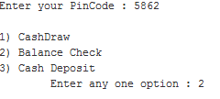Output:

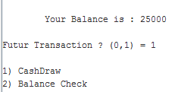

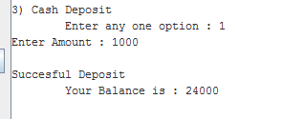

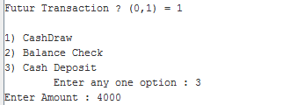

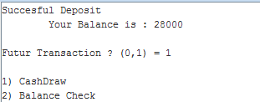

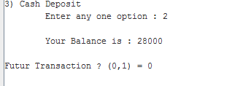

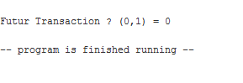

**Task # 2:**

Write a program that simulates the following c language code. ***(Read & implement scenario points carefully)***

**C-code:**

* printf("\nEnter value of num1, num2 and num3:");
* scanf("%d %d %d",&num1,&num2,&num3);
* if((num1>num2)&&(num1>num3))
* printf("\n Number1 is greatest");
* else if((num2>num3)&&(num2>num1))
* printf("\n Number2 is greatest");
* else
* printf("\n Number3 is greatest");
* return 0;

**Note: *Include registers screenshots, program and output screenshots + “.asm” file***

Solution:

.data

option1: .asciiz "\nEnter value of num1 = "

option2: .asciiz "\nEnter value of num2 = "

option3: .asciiz "\nEnter value of num3 = "

num1: .asciiz "\n Number1 is greatest "

num2: .ascii "\n Number2 is greatest"

num3: .asciiz "\n Number3 is greatest"

.text

.globl main

main:

la $a0,option1

li $v0,4

syscall

li $v0,5

syscall

move $s0,$v0

la $a0,option2

li $v0,4

syscall

li $v0,5

syscall

move $s1,$v0

la $a0,option3

li $v0,4

syscall

li $v0,5

syscall

move $s2,$v0

#check condition

bgt $s0,$s1,checknum1

b checknum2

checknum1:

bgt $s0,$s2,greater1

b checknum2

checknum2:

bgt $s1,$s2,checknum3

b greater3

checknum3:

bgt $s2,$s0,greater2

b greater3

greater1:

la $a0,num1

li $v0,4

syscall

b exit

greater2:

la $a0,num2

li $v0,4

syscall

b exit

greater3:

la $a0,num3

li $v0,4

syscall

b exit

exit:

li $v0,10

syscall

Output:

